*DEPARTMENT OF INFORMATION TECHNOLOGY* Experiment No 7

|  |  |  |
| --- | --- | --- |
| **Semester** | Semester VIII | |
| **Subject** | Devops Lab | |
| **Subject Professor In-**  **charge** | Prof. Yash Shah | |
| **Student Name** | Ashwini Jadhav | |
| **Roll Number** | 17101B0038 | |
| **Grade and Subject Teacher’s Signature** |  |  |

|  |  |  |
| --- | --- | --- |
| **Experiment**  **Number** | 7 | |
| **Experiment**  **Title** | Writing first code in puppet | |
| **Resources / Apparatus Required** | Hardware:  Compatible Computer System | Kali Linux |
| **Objectives** | To understand the concept of software configuration management | |
| **Theory** | **What is Configuration Management?**  Configuration management is the process of maintaining and establishing the performance of the products by maintaining its physical attributes, functional attributes, design, requirements, and operational information throughout its lifecycle.  The system administrators who will manually install, deploy, and configure a variety of servers and devices for the applications to run, this is a repetitive task,highly complex, and prone to errors.  In this scenario, we need to automate the process of configuring a variety of servers and devices and thus make the system's configuration faster, less error-prone, and to do it easily with some simple methods.  As you see there are tools such as Puppet, Ansible, Chef .They are the tools forconfiguration management of systems and are used extensively in the DevOps environment.  **What is Puppet in DevOps?**  The puppet is a system management tool that helps in automating and centralizing the configuration management process. It also used for softwaredeployment. It is available in open source and commercial  versions. | |

It helps in servers’ configuration management, servers’ deployments, and orchestrations of various applications across a whole lot of infrastructure in theorganization.

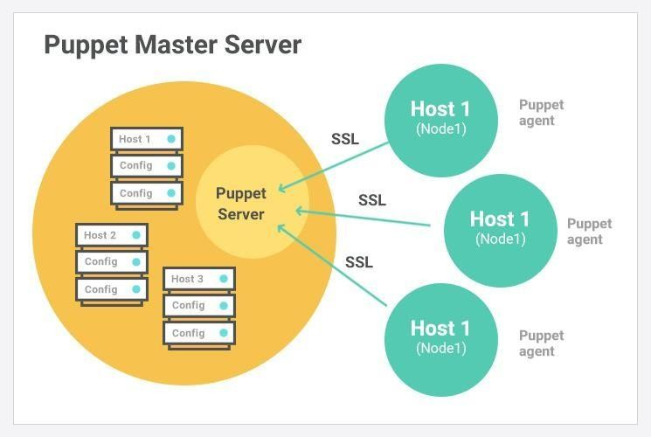

Imagine you have 100 servers, it is not possible to maintain, manage and configure the servers manually, Puppet performs the following,

* Puppet allows us to do separate configurations for every host
* It continuously monitors the server for the configurations and if theconfigurations are altered it automatically changes to a pre- definedconfiguration on the hosts.
* It has control over a whole lot of infrastructure so that the centralizedconfigurations get effected in each of the infrastructures
* It is also used as an automatic deployment tool for all the applications onthe servers.
* It implements Infrastructure as a Code, the policies and configurations are written as a code

# Output

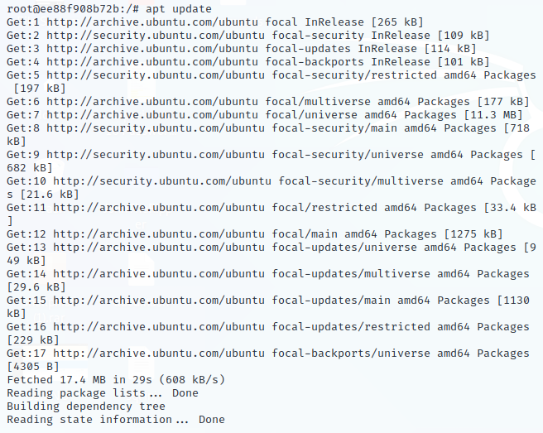

**MASTER**

Creating master container

Going inside the master container

Updating the master container

Installing nano

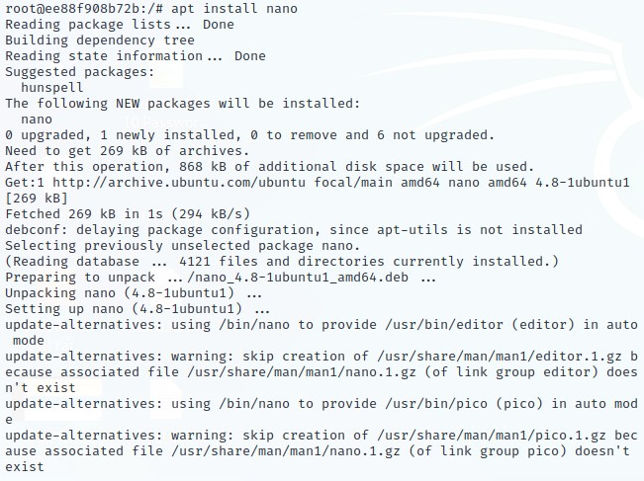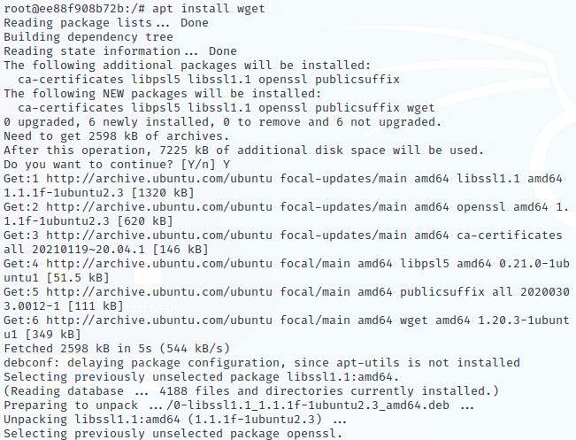

Installing wget

Going to apt.puppetlabs.com

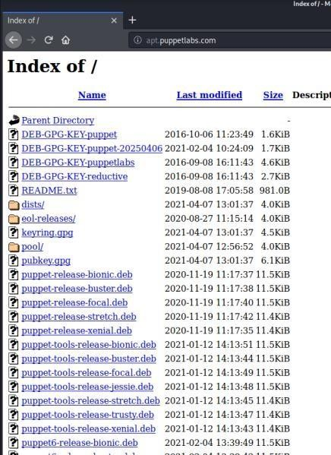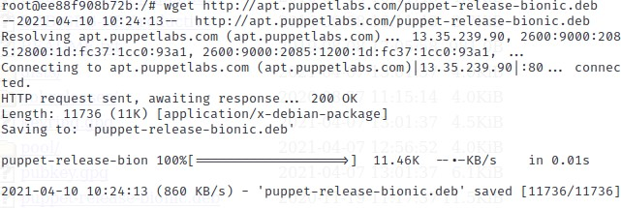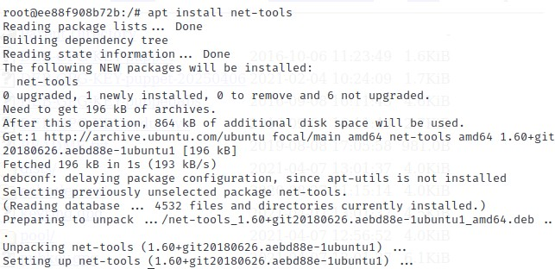

Downloading file puppet-release-bionic-deb

Installing net tools

Extracting the downloaded file

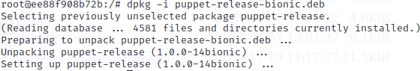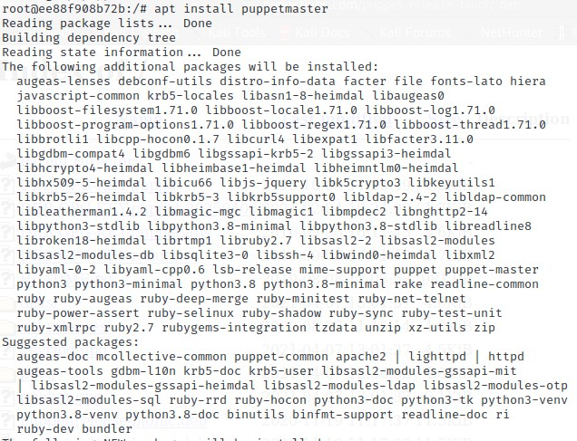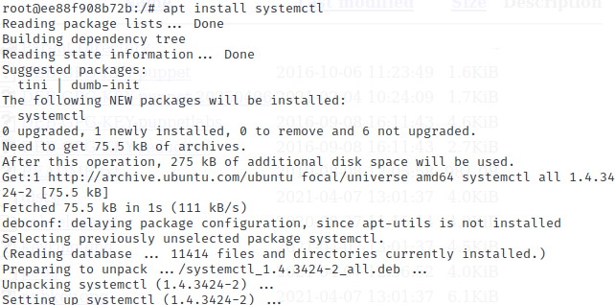

Installing puppetmaster

Installing systemctl

Restarting puppet-master service

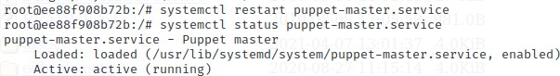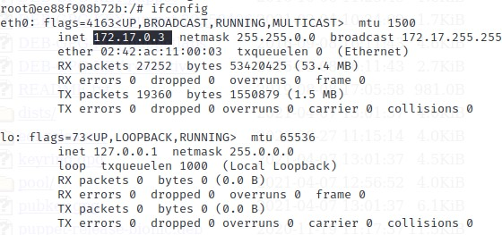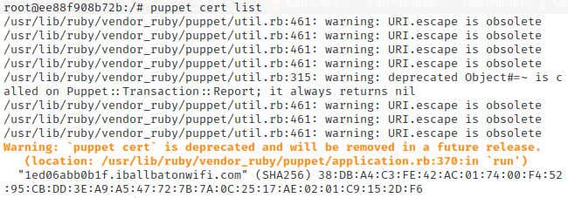

Finding ip address of master

Certificate request received by master

Signing all certificates

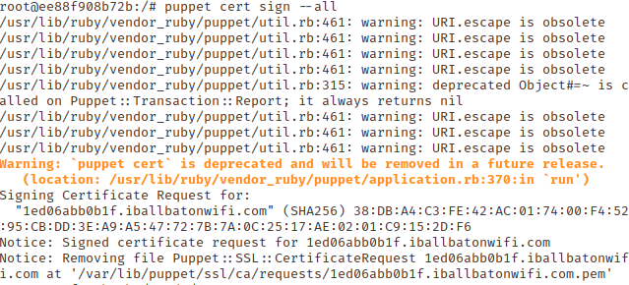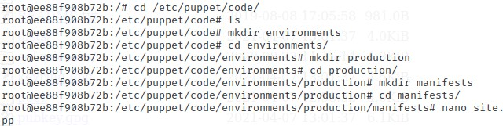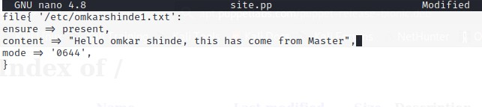

Going inside the directory to edit the site.pp file

Editing site.pp file

# SLAVE

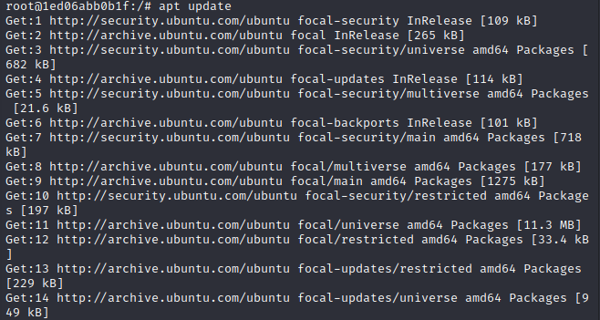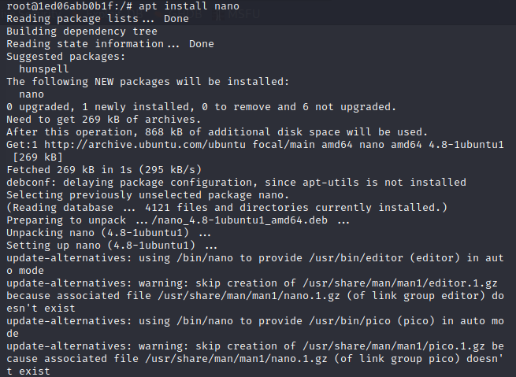

Creating slave container

Going inside the slave container

Updating the slave container

Installing nano

Installing wget

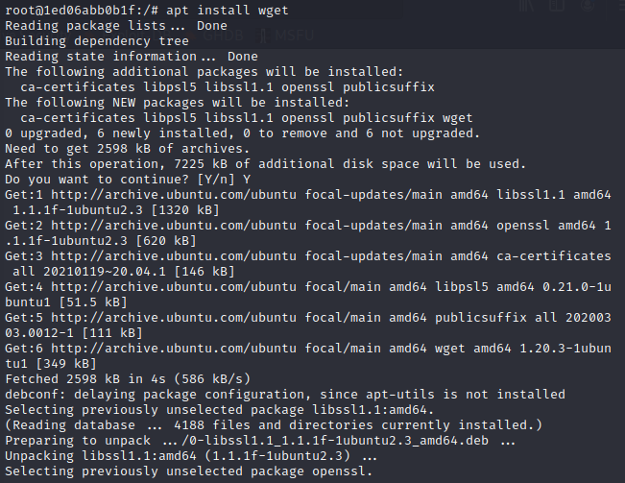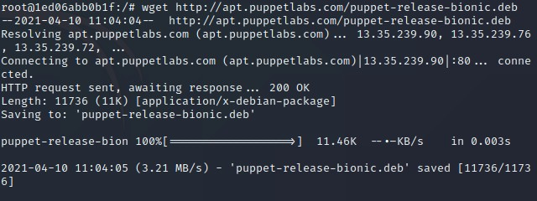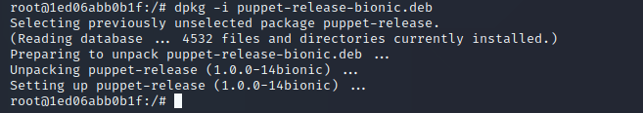

Downloading file puppet-release-bionic.deb

Extracting the file

Installing puppet

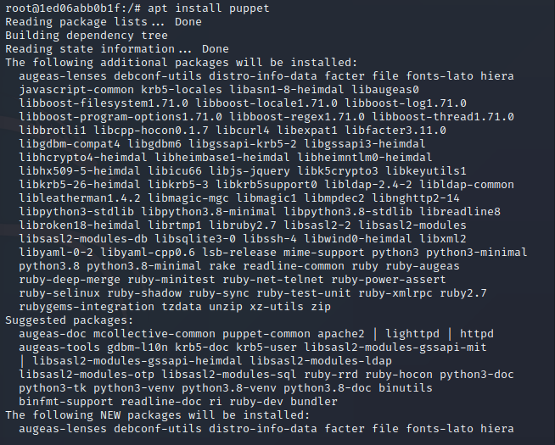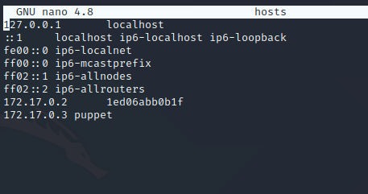

Going to hosts file and entering master ip address

Install systemctl

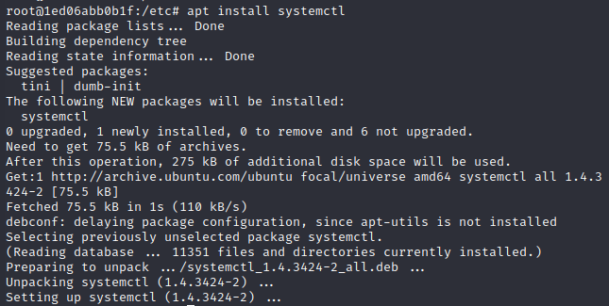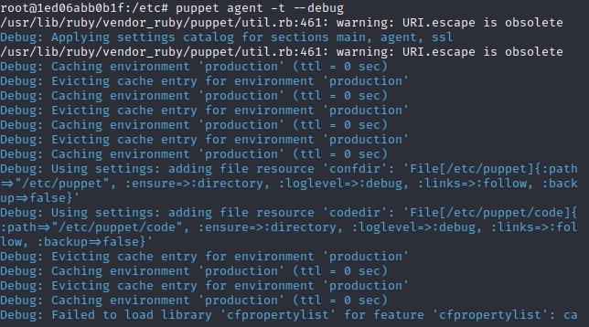

Starting puppet using systemctl

Sending certificate request

|  |  |
| --- | --- |
|  | After initializing the conversation on the slave side  13  File received on the slave side successfully  15  14 |
| **Conclusion** | Thus, we studied how to write code in puppet and use puppet as software configuration management tool. |